Dear Parents and Friends,

The Discount Card Fundraiser sponsored by the Charlton PTO to help support Heritage School, Charlton Elementary School and Charlton Middle School has been extended. We are asking for your support, but we are not just asking for money . . . we're making sure you benefit as well! As you may know, we are selling discount cards from Xtraman Fundraising. All the offers on these cards can be used unlimited times until January 2019!!

In addition to the more than 450 locations offering discounts in our area available on Xtraman Fundraising's website, they have also secured discounts for us from these additional local merchants:

CENTRAL ROCK CLIMBING GYM ● JIFFY LUBE ● OLYMPIA SPORTS ● CHILI’S ● CHUCK'S STEAK HOUSE MOHEGAN BOWL ● TED'S CHARLTON CITY PACKAGE STORE ● TRI-STATE SPEEDWAY ● FRIENDLY'S ● TEDDY G'S PUB & GRILL ● JIMMY D'S ● J ANTHONY'S ITALIAN GRILL ● FRANCESCO'S ITALIAN BAKERY ● DAD’S

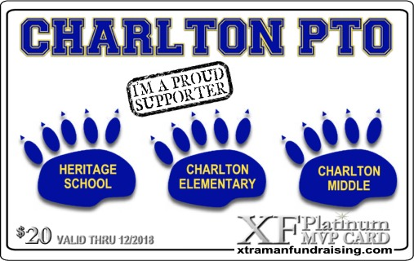
See all the details or order yours TODAY at:
www.xtramanteam.com/charltonpto.aspx
Or you can also order yours today directly from the Charlton PTO, call or text Shannon Wilk at 774-253-1749 or cut and return portion below and return to school w/ payment.

Child Name: _________________ School:_____________________ Teacher:________________

Grade: _________ Contact Number:___________________ Number of Cards:______________

