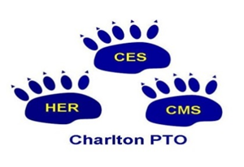

**Charlton PTO’s Baked Ham Night**

**Please join us for an amazing dinner among family and friends!**

**DATE:** Monday, February 26th, 2018

**TIME**: 1st Seating: 4:30pm - 6:15pm

2nd Seating: 6:30pm - 7:30pm

*Casual Dining * Open Seating * No Reservations*

**PRICE:** Adults $14 / Children $5 (4-12 yrs.)

**LOCATION:** Publick House, 277 Main St (Rt 31) Sturbridge

Dinner will be held in Paige Hall

**MEAL:** Baked Ham, Au Gratin Potatoes, Green Beans,

Mac & *Cheese (Also includes: Salad, Rolls, Dessert,*

*Coffee & Soft Drinks*

------------------------------------------------------------------------------------------

**Please ensure your order is in by February 16th, 2018**

*Please make all checks payable to the* ***Charlton PTO***

***\*a $15 max fee may be charged for returned checks***

**Please complete entire form**

Student Name: ________________________ Teacher: ___________________________

Phone Number: _________________ Email address: _______________________________

How Many Tickets: Adult ____ Child____ Total Amount Enclosed: ___________ Which Time: **1st Seating** from 4:30pm-6:15pm ___ Or 2nd **Seating** from 6:30pm-7:30pm ____

***Delivery methods*:** Tickets will be sent home with student ***or*** include a self-addressed stamped envelope with your check and order form and tickets will be mailed to your home.

If you have any questions, please contact Charlton PTO at [charltonpto@yahoo.com](mailto:charltonpto@yahoo.com) or Nicole Enberg at [NEnberg@unum.com](mailto:NEnberg@unum.com)

***For PTO Use:  Check # _______***