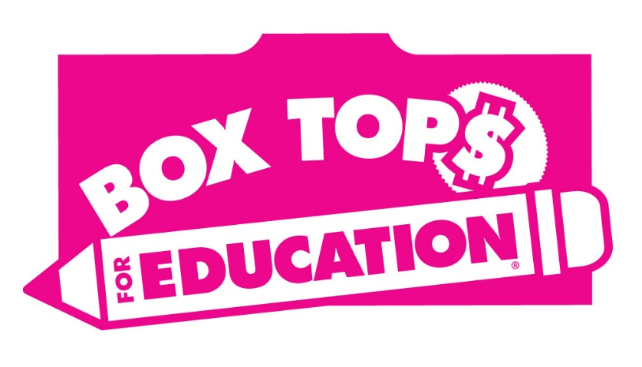
Charlton Elementary Box Top CONTEST__
Collect as many Box Tops as you can through the month of February.
Attach to the other side of this sheet ~ Photocopy if needed
Extra Box Tops may also be collected in envelope marked with amount.
Fill in name, grade and teacher ~ Return to school by February 15th

WINNING PRIZE

The Kindergarten Class and the First Grade Class with the most Box Tops submitted by Feb 15th will receive a dance party and a special snack!

In case you didn’t know…..we submit box tops in bags of 50 and we collect them ALL year long!!
Please ask friends and family to help then send them into school with your child.
1 BOXTOP = $.10

